Hocus Pocus graphics replacement guide

Table of Contents
1 Introduction 1
2 How the palettes work 2
3 How graphics data are stored in memory 4
4 How to replace a tileset 7
5 How to replace a backdrop image 9
6 How to edit sprites 12
7 How to edit other graphics 14

Introduction
This document describes how to replace all graphics in Hocus Pocus. At first you will read some theory about how the Hocus Pocus palettes work and what limitations are there, it is really useful to know. Then detailed step-by-step instructions with examples and screenshots will follow.
In Hocus Pocus there are five kinds of graphics:
- Tilesets
- Backdrop images (parallax level backgrounds)
- Sprites
- Fullscreen images
- Other non-fullscreen graphics for menus and UI
Hocus Pocus uses PCX format for tilesets, backdrop images and fullscreen graphics. Because PCX is a common publicly-known format, there are really lot of programs that can save images in this format. Hocus Pocus level editor can only import files which are already in PCX format, so you will need some external image editor to create them. Additionally the image editor needs to be able to work with palettes – edit palette and import an existing palette into true-color image (palettize it).
I am personally using IrfanView for this purpose, because this is very simple and free program. All the examples and screenshots will be performed using IrfanView, however you can use any program you like, provided that you are able to do the same job with it.
The sprite format is a custom format unique for Hocus Pocus. Therefore HocusEditor itself provides built-in functionality to view, export and import sprites directly. The other menu/UI graphics is stored in planar VGA format. HocusEditor can view, export and import these graphics files as well.

How the palettes work
Hocus Pocus actually uses two separate palettes at a time: one being the lower 128 colors and the second being the upper 128 colors of 256-color VGA palette.
The "lower" palette is fixed through all the game and is stored in GAMEPAL.PAL file inside HOCUS.DAT. The "upper" palette is variable and is bound to a specific backdrop image. In other words, each backdrop image (BACKxx.PCX) has its own palette (BACKxx.PAL). The menu graphics has also its own palette (MENUPAL.PAL).
All the original game tilesets and sprites use only colors within palette indexes 0 - 127. And all the backdrop images consist only of colors with indexes 128 - 255.
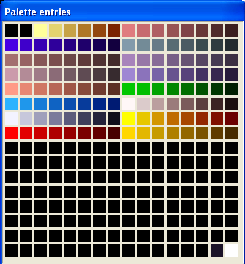
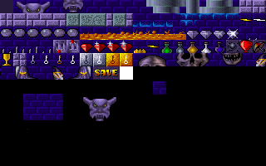
The palette is stored inside .pcx file. You can open it in IrfanView and Click
"Image –> Palette –> Edit palette" to see the palette.
This palette comes from TILES01.PCX file, and is the same for all tileset images (and sprites).
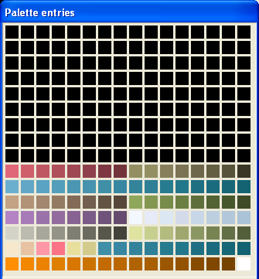
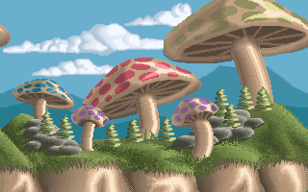
This palette comes from BACK01.PCX file. Each backdrop image has its unique palette.

If you are making your custom graphics, the backdrop image actually may contain fixed colors from range 0 - 127 and for the rest colors (128 - 255) you can make your own palette. Just remember to save your upper palette into BACKxx.PAL file as the game ignores the palette internally stored in PCX file itself. The editor provides an option to automatically do it during importing the backdrop image, as shown later.
Oppositely, you can use colors from range 128 - 255 in a tileset and sprites, but remember that the tileset and sprites must be bound to a specific backdrop image with the same upper palette. Because the upper palette depends on backdrop image which is used in current level.

How graphics data are stored in memory
Hocus Pocus actually uses VGA memory to store all graphics (the memory chips are located directly on the graphics card). It uses planar VGA mode, which provides 4 planes of 64k size, meaning 256 kilobytes of video memory total. Two planes are used for storing the screen contents (with double-buffering), leaving the two other planes (about 128 kilobytes) for storing graphics. Rendering is performed just by copying data from one area of VGA memory to another.
That unfortunately means that there is a limit of how many tiles in the tileset and how many sprites can be used in a level. The 128 kilobytes of available memory is shared by tiles, sprites, and backdrop image data. The backdrop image is 320*200, so it takes 64000 bytes, almost half of the available memory.
Here is an example of how this memory area is used:
TTTTTTTTTTSSSSSSSSSSXXBBBBBBBBBBBBBBBBBBBB

T = Tileset data
S = Sprite data
X = Free space
B = Backdrop image data
The size of tileset data depends of how many tiles are used in tileset (see later how it works). Sprite data are stored immediately after tileset data. Some sprites are loaded always automatically (the player, score tags etc.) and after that monster sprites are loaded, depending on which monster types are used in a level. Backdrop image data have fixed size and are always loaded at fixed position.
If you use too many monster types in a level, the pixel data of the "highest" sprites will load into memory area reserved for a backdrop image. Because backdrop image is loaded after sprites (in time order), the sprites will get overwritten with it. The same happens if there are too many tiles in tileset - the sprite data are pushed away to the area reserved for backdrop image and will get overwritten too.

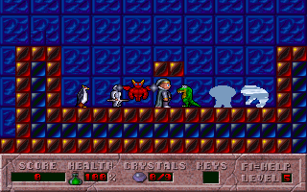
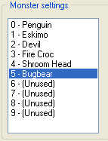
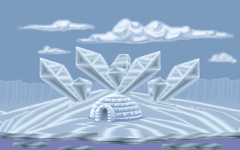
This is an example of what happens if there are too many sprites used in a level.
The Polar tileset uses the most tiles of all tilesets (135), leaving even lower memory space for sprites. The pixel data of Shroom Head and Bugbear (and also Fire Croc, partially) got overwritten by pixel data of the backdrop image, as can be clearly seen. The layout data are stored in the main memory, so the shape of sprites is not affected.

Now how the number of tiles in tileset is determined. The 320x200 tileset image is not loaded into memory as a whole, but it is being stored tile by tile. After the last used tile follows a special "white tile" which is marking the end of tileset and telling the game to stop loading data. The empty part of tileset after this white tile is ignored. The white tile is actually fully made of pixels with palette index 255.
There is effective limit of 135 tiles and 3 simultaneous monster types in a level (that's reached in E1L5 and E1L6). In some levels there are more (even 4 or 5) monster types, but less tiles in the tileset. So this is always a trade-off.
Notice the "white tile" after the last "effective" tile in tileset. It can be actually any color, important is that the color is palette index 255.
If you place tiles beyond the last tile into your level, they will contain pixels from the sprites (most probably the player sprites because these are first sprites loaded).

HocusEditor provides a handy feature which computes the usage of VGA memory and tells you whether you exceeded the limits or not and how much free memory is remaining. You can find it in the "Level Properties" dialog: click the "VRAM Usage..." button in the bottom-right corner.
The advantage is that you can see the memory usage while you are configuring the monster types available in your level. When you add a new monster, the usage is dynamically recomputed and you can immediatelly see if the game can handle it.

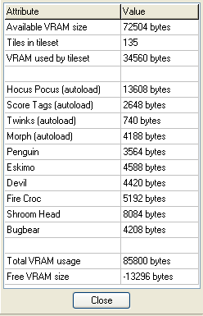
Notice how much monster types are used, so the available memory size is exceeded by 13 kB .

How to replace a tileset
- Get or create a tileset image. The image must be 320x200 size, each tile must be 16x16 pixels. The tileset must contain max. about 135 tiles, otherwise it won't leave enough memory for sprites.
- After the last tile insert an end-marker tile to mark the ending of tileset. The rest of image should be black. The end-marker tile does not need to be white (like it is in all the original tilesets) but can be actually any color which is not used in the tileset.

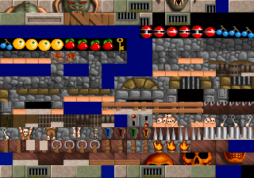
For this example I'm using the "Dungeon" tileset from Vinyl Goddess from Mars.
The image is 320x224 pixels and contains too many tiles. Furthermore, it also has many unused "blue" tiles which are worthless and need to be removed.
I rearranged the tileset and removed all the blue tiles. I also reduced the number of tiles – it now contains 129 tiles, the rest is blacked out and image size is 320x200. I used magenta color for the end-marker tile because white color is already used within the tileset.
- Extract Hocus Pocus palette from any original tileset .pcx image. In IrfanView can be done by "Image" – "Palette" – "Export palette" option. The palette will be saved as .pal file which is in text format, easily editable with any text editor. Here is example of the contents of .pal file:
JASC-PAL
0100
256
0 0 0
0 0 0
255 255 155
227 211 111
...
255 255 255

If you used different color than white for the end-marker tile, change the last color in the palette into that color.
- Open your tileset image in IrfanView and use "Image" – "Palette" – "Import palette" and use the palette you previously extracted. The image will be palettized. Then save the image in PCX format.
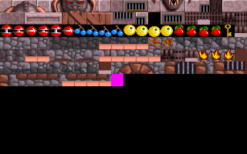
This is how the tileset looks like after palettizing. The colors are pretty screwed up and don't look very good, but in this example let's not bother about it.
- Open Hocus Pocus level editor and use "Tools" –> "Import file" option. Select a tileset image you wish to replace (TILESxx.PCX) and then select your pcx file you just saved. Your custom tileset will be imported and ready to use.
- You can make tileset configuration for your new tileset, which tells the editor which tiles should be used only in background layer or foreground layer, and which tiles are used for pick-up items. It also contains the block and pattern presets.
To create the configuration, go to Tilesets folder and edit the .ini file of the tileset you just replaced. (Tip: you can create a new empty level, and paint the background, foreground and item tiles into a 8x8 block, which is equivalent of the window on the right side of editor where you choose tiles from. Then select that 8x8 block in block mode and use "Save block as preset" option. Then open up the .ini file and copy+paste the block preset you just created this way.)

How to replace a backdrop image
- Get or create an image you would like to use as a backdrop. The image must be 320x200 size. You can actually black-out the lowest 40 pixels of the image, because they will be never seen in-game (the status bar will always cover them – viewport size is 320x160 pixels). This way you will reduce the size of the resulting pcx file.
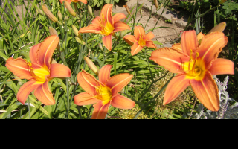
For this example I chose a random picture I took with my camera.
- Open the image in IrfanView and use "Image" –> "Decrease color depth" option. Type in 127 colors and click OK. The program will create 127-color palette of the image.
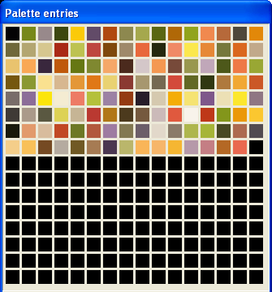
This is the resulting palette made of 127 mostly-occuring colors in the original picture.

- Export the palette into .pal file. Edit the .pal file this way: move the 127 colors from the lower half of the palette into the upper half of the palette. Make the last color white (255 255 255). Optionally you can insert the tileset palette into the lower half of the palette. This way you will be able to use full 255-color palette (some colors from the tileset palette may be utilized in the backdrop image too, slightly increasing its quality).
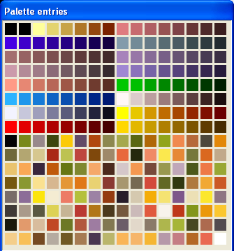
This is how the final palette looks like.
- Open the original true-color image in IrfanView again. Import the palette you just created. Then save the image in PCX format.
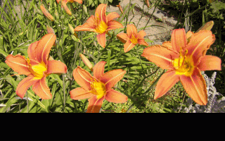
This is the result. The picture uses 146 unique colors and the quality is not reduced very much.
- Open Hocus Pocus level editor and use "Tools" –> "Import file" option. Select a backdrop image you wish to replace (BACKxx.PCX) and then select your pcx file you just saved. After importing the file, the program asks you whether to save the upper part of palette from pcx file. Click Yes. Done.
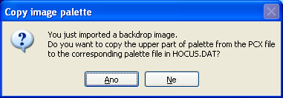
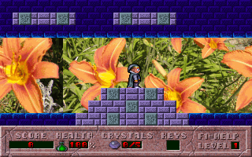
This is how it looks in-game. Notice the rough transition between the left and right side of the picture. All the original backdrops are horizontally repeatable, so they appear as a single big continuous picture.
- You actually can use the upper part of palette in your tileset to make the tileset look much better. To achieve this you must create a backdrop image (or just the upper palette) that contains the proper colors. You will need to use only that backdrop image with your tileset.

How to edit sprites
Editing of sprites is more complicated. All the sprites are divided to groups called "sprite sets", each sprite set contains all sprites for a monster type. The first 4 sprite sets are reserved for the player sprites, score tags and twinks and are always loaded into memory in any level. There are 40 sprite sets total, meaning there are 36 different monster types, 2 of them are unused.
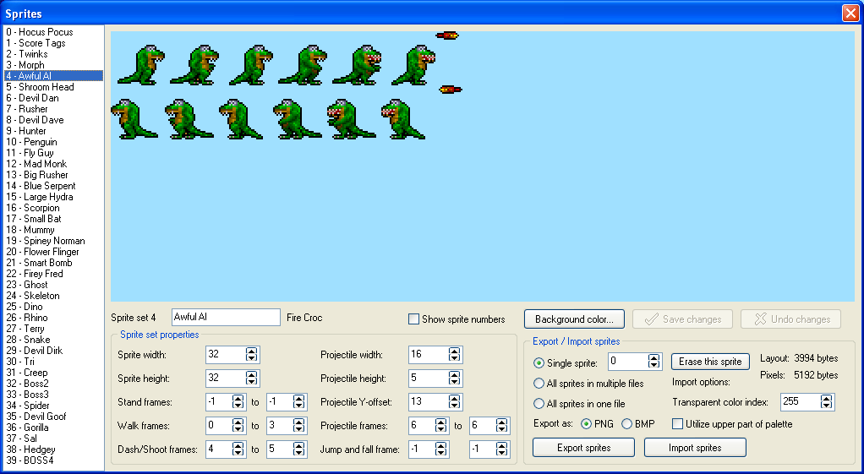
There can be up to 40 sprites (let's call them frames) in a sprite set. Notice that there are frames for both left and right directions, meaning there can be up to 20 right-facing frames and 20 left-facing frames. Each frame has its index: right-facing frames use indexes 0-19 and left-facing frames use indexes 20-39 (basically index of the counterpart frame + 20).
In the "Sprite set properties" box you can configure which frames are used for which monster states (walking, dashing, shooting) and for the projectile. For Hocus Pocus (player) you can also configure stand, jump and fall frame. The width and height defines the hitbox of a monster or projectile (while the sprite itself can be smaller or bigger). It seems that changing the size does not affect the hitbox of Hocus Pocus. The number of frames used in sprite set is determined by the highest number used in sprite set properties.
You can export and import sprites in three modes:
- Single sprite – you just choose the frame index and export that sprite into a separate file. Tip: you can click into the sprite view image to quickly select the frame index. Check "Show sprite numbers" option to easily see the indexes.
- All sprites in multiple files – when you choose target filename for example "firecroc.png", it creates files "firecroc_00.png", "firecroc_01.png", ..., "firecroc_20.png", ... and saves all the frames one by one into them.
- All sprites into one file – everything is saved into one file, arranged in same way as in the sprite view image.

Importing sprites works in the opposite way, you basically provide the same input as what is the result of the respective export method. For "All sprites in multiple files" mode, you select any of the input files (for example "firecroc_00.png") and the program automatically searches for the other existing files with different numbers and imports them too.
If you want to import more frames than are currently used in the sprite set, you must increase the numbers in "Sprite set properties", otherwise you won't be able to see them.
When importing a sprite (it can be in either .bmp or .png format), the shape (transparent pixels) of a sprite is determined by a transparent color. If you import a 256-color paletted image, you can configure which color index is used for transparency (for the exported sprites it is 255). If you use -1 as color index, then the top-left pixel color is used. If you import a true-color (24bpp) image, then the transparent color is also determined by top-left pixel. PNG transparency cannot be used, because it was not possible to implement it.
HocusEditor automatically palettizes the imported image, so you can provide image which is either already created using the Hocus Pocus palette or not. If "Utilize upper part of palette" option is turned off, then only the lower 128 colors from palette are used. This is the safe option, because these colors are always the same across all the game and levels. The upper 128 colors are bound to a specific backdrop image and can be different in different levels. You can take advantage of the upper part of palette of course: with "Utilize upper part of palette" option the palette of currently loaded backdrop image is used, so you must open up the respective level in the editor first. Do this only if you know what you are doing.

How to edit other graphics
The menu/UI graphics can be viewed, exported and imported in "Tools" -> "Graphics" dialog. All the graphic files are in planar VGA format and can have any size (width must be multiply of 4).
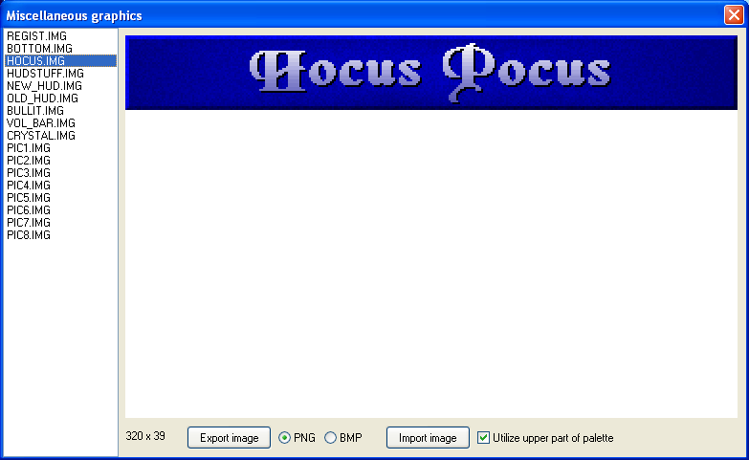
You must take special care about palettes. The menu graphics uses its own menu upper palette MENUPAL.PAL (as the image shown in the above example), while in-game UI (for example hud) should use only the lower part of palette. If you enable "Utilize upper part of palette" option, then the menu palette is used.
The image REGIST.IMG is very special case, it uses the palette from title screen image (TITLE.PCX).

The fullscreen images (Apogee logo, title screen, future level previews, ending screen etc.) are stored in PCX format. You can view and edit these images by imporing and exporting a file from archive (HOCUS.DAT), in similar way like tilesets and backdrop images.
These fullscreen images may use their own palette, which is different from any other palette used by the game. The palette is built-in in the PCX file itself and is utilized by the game.

